**Annexure – VIII**

**UNIVERSITY GRANTS COMMISSION**

**BAHADUR SHAH ZAFAR MARG**

**NEW DELHI – 110 002**

**PROFORMA FOR SUBMISSION OF INFORMATION AT THE TIME OF SENDING THE FINAL REPORT OF THE WORK DONE ON THE PROJECT**

1. Name and Address of The Principal Investigator:

Joe Kizhakooden, Assistant Professor, Dept. of Physics, St. Thomas’College, Autonomous, Thrissur-680001.

2. Name and Address of the Institution:

St.Thomas’ (Autonomous) College, Thrissur, Kerala

3. UGC Approval No. And Date:

MRP(S)/13-14/KLCA019/UGC- SWRO dated 15-02-2014

MRP(S)-0607/13-14/KLCA019/UGC- SWRO dated 28-03-2014

4. Date of Implementation: 9th July 2014.

5. Tenure of The Project: 2 years.

6. Total Grant Allocated: Rs.2,00,000/-

7. Total Grant Received: Rs. 1,76,000/-

8. Final Expenditure: Rs.2,04,679/-

**9. TITLE OF THE PROJECT:** “**Radiation properties of metamaterial loaded microwave horn antennas**”

**10. OBJECTIVES OF THE PROJECT:**

* The first objective of the work is the design and fabrication of metamaterial structures with negative permittivity.
* The second objective of the work is the study of the radiation parameters of the microwave horn antennas with fabricated metamaterial loading.

**11. WHETHER OBJECTIVES WERE ACHIEVED:**

The metamaterial structures with copper wires are fabricated. The different structures are made by varying the thickness of the wires and also by varying the distance between the wires. These structures are inserted inside the horn by varying the distance from the aperture. It is found that the gain and beam width of the standard horn could be varied by the insertion of the metamaterial wire structures.

**12.** **ACHIEVEMENTS FROM THE PROJECT**:

The study of radiation properties of metamaterial inserted microwave horn antennas are done. The introduction of wire materials inside the horn caused the changes of its gain and beam width. The results are also helped to complete the projects of M.Sc. students.

**13. SUMMARY OF THE FINDINGS:**

The radiation characteristics of the wire structure loaded horn antenna is studied. The different wire structures are made by varying the parameters like thickness of wire (T), the distance between the wires (D) and the distance of the wire structure from the aperture of the antenna (B). These wire structures are inserted inside the horn in the E plane and H plane. Both the E plane and H plane radiation patterns are drawn and studied.

The wavelength of the microwave used is measured as 4.375cm throughout the experiment. The X band transmitter horn is excited with the Klystron oscillator and the wire structure inserted horn is used as receiver and it is rotated using the turn table and the characteristics are plotted with software.

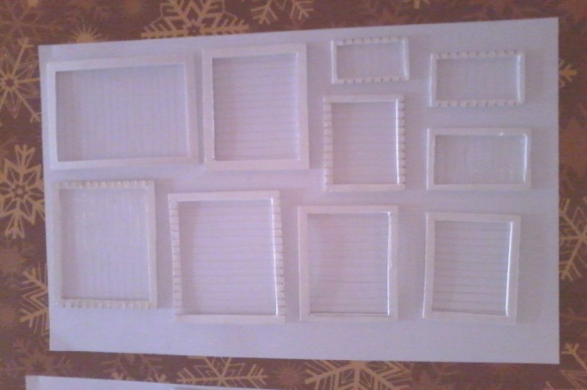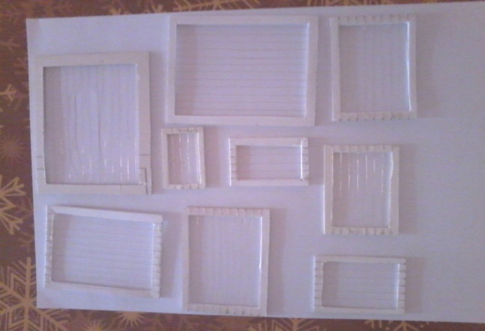

Fig.1 The different copper wire structures

The experimental set up is as shown in the figure. The standard X band horn is used as transmitter. The wire structure inserted horn is used as receiver. The distance between the transmitter and receiver antennas is kept at 82cm for far field.

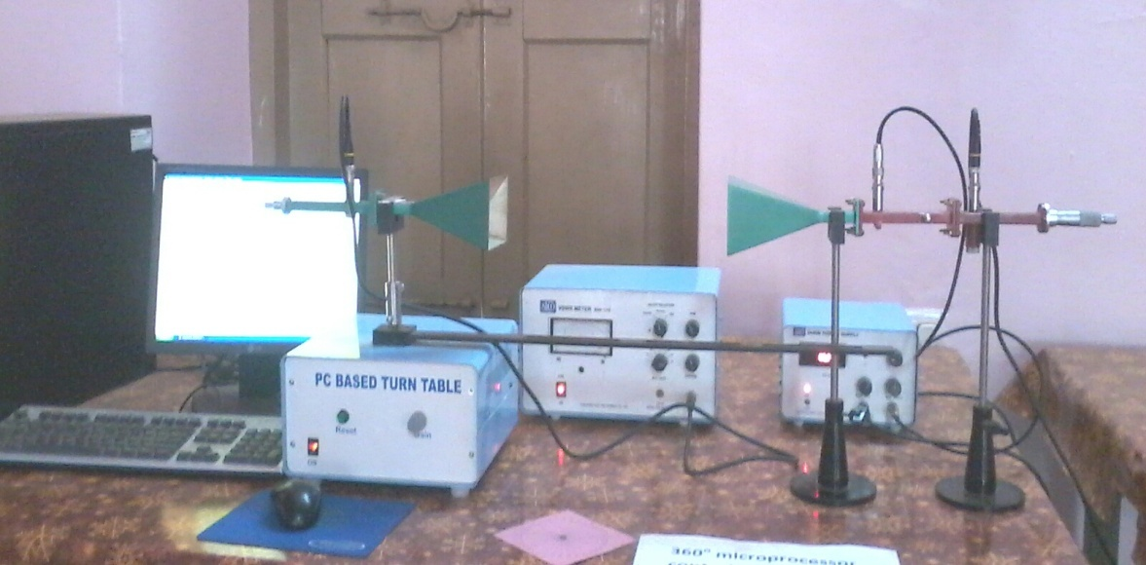

Fig. 2 The experimental setup

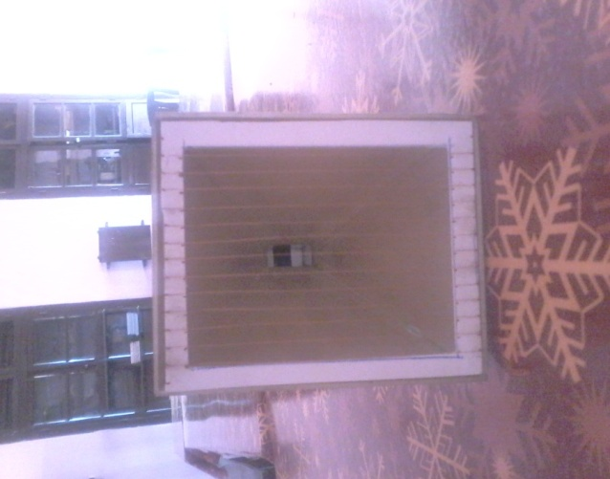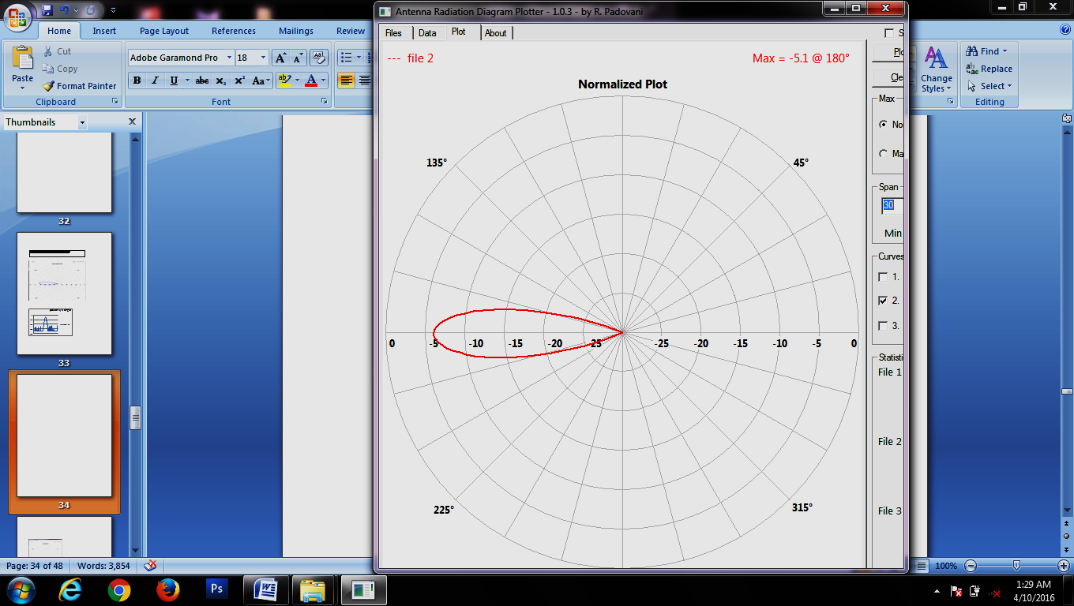

Fig. 3 The wire structure inserted horn in which the wires are perpendicular to the E plane.

Fig. 4 An example of the radiation pattern drawn by the software

The E plane radiation patterns are drawn with the wires parallel to the electric field and for the wires perpendicular to the electric field at the aperture. The radiation patterns are drawn again by varying the distance between the wire structure and the aperture. The experiment is repeated by varying the thickness of the wires and also with the distance between the wires in the wire structure. Similarly the H plane radiation patterns are also drawn for the different cases.

From the results, it can be concluded that the horizontal wire structure in the H plane gives the radiation pattern of original horn without wire structure and the beam width of the antenna can be decreased by moving the wire structure into the aperture of the antenna and also the gain can be increased by the same method. By varying the thickness of the wire, the beam width is increased such that the directivity is decreased. By increasing the inter wire distance, there is a change in the shape of the radiation pattern for a particular wavelength.

The vertical wire structure in H plane and E plane is not useful as the radiation pattern has the gain less than -20db and has less directivity as the beam width is high.

**14. CONTRIBUTION TO THE SOCIETY:**

The horn antenna with wire structures are useful to decrease the beam width thereby increasing the directivity of the antenna. So we can detect the different sources of radiations which are nearby like stars in the distant galaxies. Also it can be used in the satellite communications. We can send the signals to or receive signals from the satellites which move close.

(PRINCIPLE INVESTIGATOR) (REGISTRAR/PRINCIPAL)