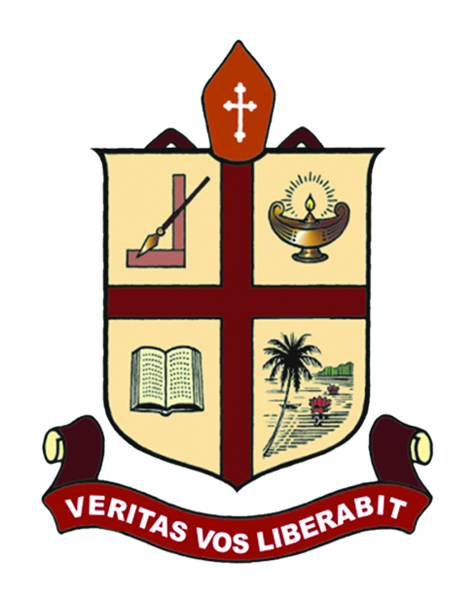

RESEARCH & POSTGRADUATE DEPARTMENT OF CHEMISTRY
ST. THOMAS’ COLLEGE (AUTONOMOUS),
THRISSUR-680001, KERALA, INDIA.

“CHEMISTRY IN CAPILLARIES”
NATIONAL WORKSHOP ON MICROSCALE ANALYSIS

29th & 30th July, 2015
Menachery Hall

Sponsored by
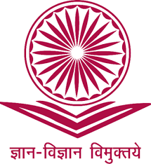
UNIVERSITY GRANTS COMMISSION

PROGRAMME SCHEDULE

29th July 2015 | 30th July 2015
9:00 – 9:30 Registration | 9:30 – 10:30 Technical Session - III  Dr. V. D. John  Christ College, Irinjalakuda
9:30 – 10:00 Inauguration | 10:30 – 11:30 Technical Session – IV
Dr. Jenson P.O., Principal | Dr. K. V. Sudhakaran  M.C.C., Calicut
10:00 – 10:30 Technical Session - I | 11:30 – 11:45 Tea Break
Dr. S. Murugan | 11:45 – 01:00 Laboratory Session – III
S T H College,Nagercoil | Physical Chemistry Lab
10:30 – 11:00 Technical Session – II  Dr. John P. R.  Govt. Victoria College, Pkd | 1:00 – 2:00 Lunch Break  2:00 – 4:00 Laboratory Session – IV  Organic Qualitative Analysis  Organic Preparation
11:00 – 11:15 Tea Break
11:15 – 01:00 Laboratory Session – I
Quantitative Analysis
02:00 – 04:00 Laboratory Session – II
Inorg. Qualitative Analysis

For registration and other details please contact:
Convener
Dr. Sunil Jose T
Mob: 9495039701. Email : sjtppc@gmail.com
Joint Conveners
Dr. Jency Thomas
Mob: 8281492841 Email: jencyiitd@yahoo.co.in
Prof. Reeja Johnson
Mob: 9497317062 Email: reejajoh@gmail.com

No Registration fee. No. of delegates restricted to 50.
Last date for registration: 27 July, 2015

