EXECUTIVE SUMMARY REPORT OF THE WORK DONE ON THE FINAL RESEARCH PROJECT

1. Name and Address Of The Principal Investigator:
Nees Paul, Koola House, Laloor Road, Aranattukara P.O. Thrissur.
2. Name and Address of the Institution:
St.Thomas’ (Autonomous) College, Thrissur, Kerala
3. UGC Approval No. And Date:
Mrp(S)-0606/13-14/Klca019/UGC-SWRO Dated 28 March 2014

TITLE OF THE PROJECT:
“Development of frequency selective split resonator metamaterial structures using conducting Polymers”
OBJECTIVES OF THE PROJECT:
- Design and development of a SRR metamaterials at microwave frequency using conductive polymers.
- We aim at producing highly flexible Electromagnetic Metamaterials
- Development of high efficiency miniaturized frequency selective structures which can be fabricated in lab and commercial scale for communication and sensing applications.
WHETHER OBJECTIVES WERE ACHIEVED:
The good quality films formed by the paste of the PVA and chlorine doped Polyaniline on different substrates is cracked when it pasted on cloth and paper. The proposed objective of screen printing the SRR on flexible substrate seems to be little inefficient so we made a water proof coating of Polytetrafluroethylene on the screen printed SRR structures fabricated on the flexible substrates like ohp sheets and papers. We started with the preparation of Polyaniline films by directly pouring PANI solution in the glass substrate , but the film then formed is very thin and it shows low conductivity. So we tried to make thick films on the same substrate by increasing the polymerization and curing time. But after washing with acetone the result remains same. So we decided to use an adhesive to enhance the bonding between polymer and substrate. We thought of a poly-synthetic resins and selected ethylene vinyl acetate, which is coated on glass before Polyaniline is poured. The film thus formed is then washed with water and air dried. Then the film thickness can be controlled but it cannot be made uniform and also small lumps are formed inside the film. Next we use hot water soluble PVA dissolved it at 80⁰c in water. The PANI powder which is prepared is added to PVA solution by constant stirring to confirm proper mixing. After 30minutes vigorous stirring at 80⁰c the viscous liquid is then pasted on different substrates like cotton, OHP films, glass etc. The films thus formed shows high conductivity and have uniform thickness.
ACHIEVEMENTS FROM THE PROJECT:
The SRR prepared and the sheet formed using the Polyaniline is used for the absorbance and transmission and reflection studies of two M.Sc students for their completion of their Project report.
SUMMARY OF THE FINDINGS:
The variation of dc electrical conductivity of the PANI films prepared by three methods with temperature is conducted using standard 4-probe set-up where the sample film was kept inside an oven. The temperature was varied from room temperature to 374K. It is observed that at low temperatures the dc electrical conductivity increases with increasing temperature. But high temperatures the conductivity is inversely proportional to temperature. The increase of conductivity until the critical point is attributed to polymer chain mobility and activation of dopant. At higher temperature region as the temperature increases the molecules are set into vibrations resulting in a decrease in the mobility of the charge carriers due to scattering. The vibrating molecules slightly distort the ordering/crystallinity of the polymer system. The change of chain structure by thermal treatment and interchange interaction between two components has an effect on morphological change. So the slight distortion in the ordering is the prime factor for the observed decrease in electrical conductivity. The sheets and films of chlorine doped polyaniline and polyaniline nanocomposites act as a hybrid material which behaves as semiconductor at low temperature and as metal at high temperature.
Analyzing the inverse proportionality between conductivity and temperature above a particular temperature the critical point of the chlorine doped polyaniline, chlorine doped polyaniline with pva film, silver doped polyaniline and polyaniline sheet correspondingly are 328k, 314k, and 318k .
When we analyzing the XRD pattern of the chlorine doped polyaniline it agrees with the reported spectrum. It has semi crystalline nature with higher intensity peaks at around 17º , 26º and lower intensity crystalline peaks at 14º,16º,19º,23º 25º 30º. Consider the XRD pattern of silver doped polyaniline, sharp peaks of the XRD pattern indicate that the synthesized nanocomposite is well crystalline and confirms the formation of single crystalline Ag nanoparticles in PANI/Ag . Pure polyaniline shows two peaks of 2θ at ~ 20° and 28° which correspond to (100) and (110) crystal planes as shown in figure 1. Bragg’s reflections at 2θ = 38.2, 47.462, degree corresponds to {111}, {200}, lattice planes, respectively, for the face-centered cubic (fcc) structure of silver nanoparticles embedded in PANI
Figure 1: XRD of polyaniline powder
XRD
Operations: Smooth 0.150 | Import
ST T SAMPLE-3 - File: ST T SAMPLE-3.raw - Type: 2Th/Th locked - Start: 5.000 ° - End: 60.000 ° - Step: 0.010 ° - Step time: 0.3 s - Temp.: 25 °C (Room) - Time Started: 0 s - 2-Thet
Intensity (Arb. Units)
0
10
20
30
40
50
60
70
80
2-Theta - Scale
5
10
20
30
40
50
60
2T=19.184 ° d=4.62266
2T=28.385 ° d=3.14167
2T=38.575 ° d=2.33198
2T=47.462 ° d=1.91400
The study of microwave properties of conductive polymers is crucial because of their wide areas of applications such as coating in reflector antennas, coating in electronic equipments, frequency selective surfaces, satellite communication links, microchip antennas, radar absorbing materials etc. Study of the, conductivity electric constant, and absorption coefficient of these polymers in microwave region will highlight their application in these fields.
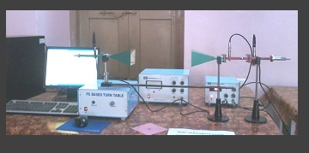
The absorption coefficient A can be obtained from the simple relation A+R+T = 1 indicating that the absorbed power is A .It is the measure of how much the radiation absorbed. In this study we are trying to find the s parameters using network analyzer. The transmission coefficient of polyaniline with thickness 3mm and 5mm can be calculated from figures. The reflection coefficient of polyaniline with thickness 3mm and 5mm can be calculated from figure 3. Radiation pattern observed from figure 4, pattern formed without specimen rate of absorption is -68db .Pattern formed by placing very small specimen in the inner side of horn antenna rate of absorption is -54.4db.Pattern formed by placing small specimen in the inner side of horn antenna rate of absorption is -46.8db.Pattern formed by placing small specimen in the outer side of horn antenna rate of absorption is-58.5db.Pattern formed by placing large specimen in the outer side of horn antenna rate of absorption is-58.8db.Rate of absorption of microwave increased when polyaniline is place in horn antenna so it is clear that POLYANILINE absorbs microwave radiations. Figure 5 gives the s21 and s11 characteristics of the SRR constructed using Polyaniline which shows proper resonance.

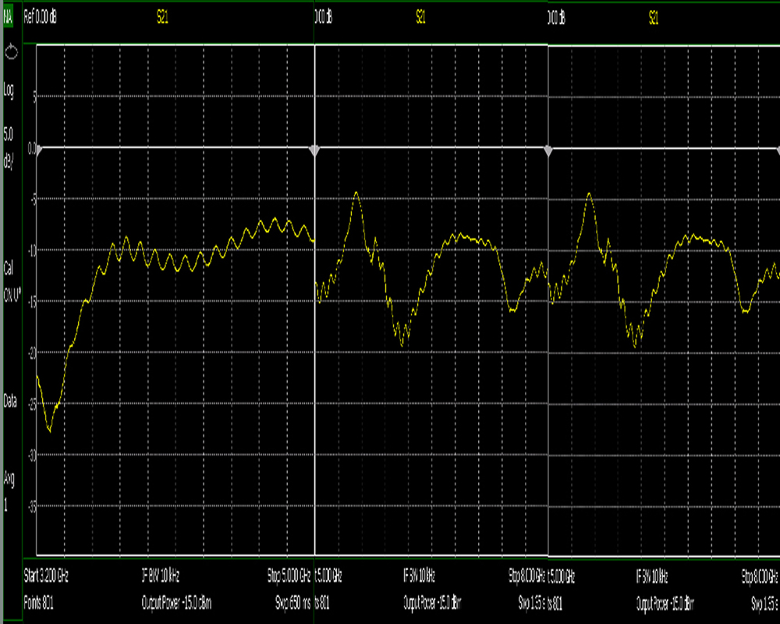
Figure 2 : S21 and S11 of the polyaniline powder

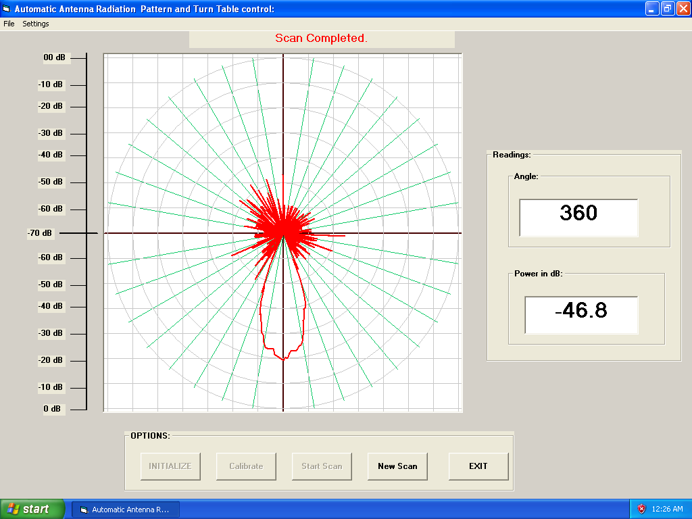
Figure 3: radiation pattern of the sheet

Figure 4: s21 and s11 of the polyaniline srr

14. CONTRIBUTION TO THE SOCIETY:
The prepared sheets and SRR’s have large potential industrial applications at microwave and millimeter waves are clearly centered on: frequency selective communication systems, sensing and imaging systems etc. Intense further analysis and research will however be necessary to ascertain these concepts will prevail. The flexibility and higher efficiency for the given range of frequency enhances its uses in sensors and anechoic chambers for absorption and filtering.

